**Java Classes/Objects**

Java is an object-oriented programming language.

Everything in Java is associated with classes and objects, along with its attributes and methods. For example: in real life, a car is an object. The car has **attributes**, such as weight and color, and **methods**, such as drive and brake.

A Class is like an object constructor, or a "blueprint" for creating objects.

Create a Class

public class Main {

int x = 5;

}

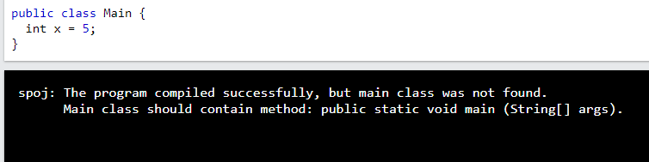

### Example

Create an object called "myObj" and print the value of x:

public class Main {

int x = 5;

public static void main(String[] args) {

Main **myObj** = new Main();

System.out.println(myObj.x);

}

}

### Example

Create two objects of Main:

public class Main {

int x = 5;

public static void main(String[] args) {

Main **myObj1** = new Main(); // Object 1

Main **myObj2** = new Main(); // Object 2

System.out.println(myObj1.x);

System.out.println(myObj2.x);

}

}